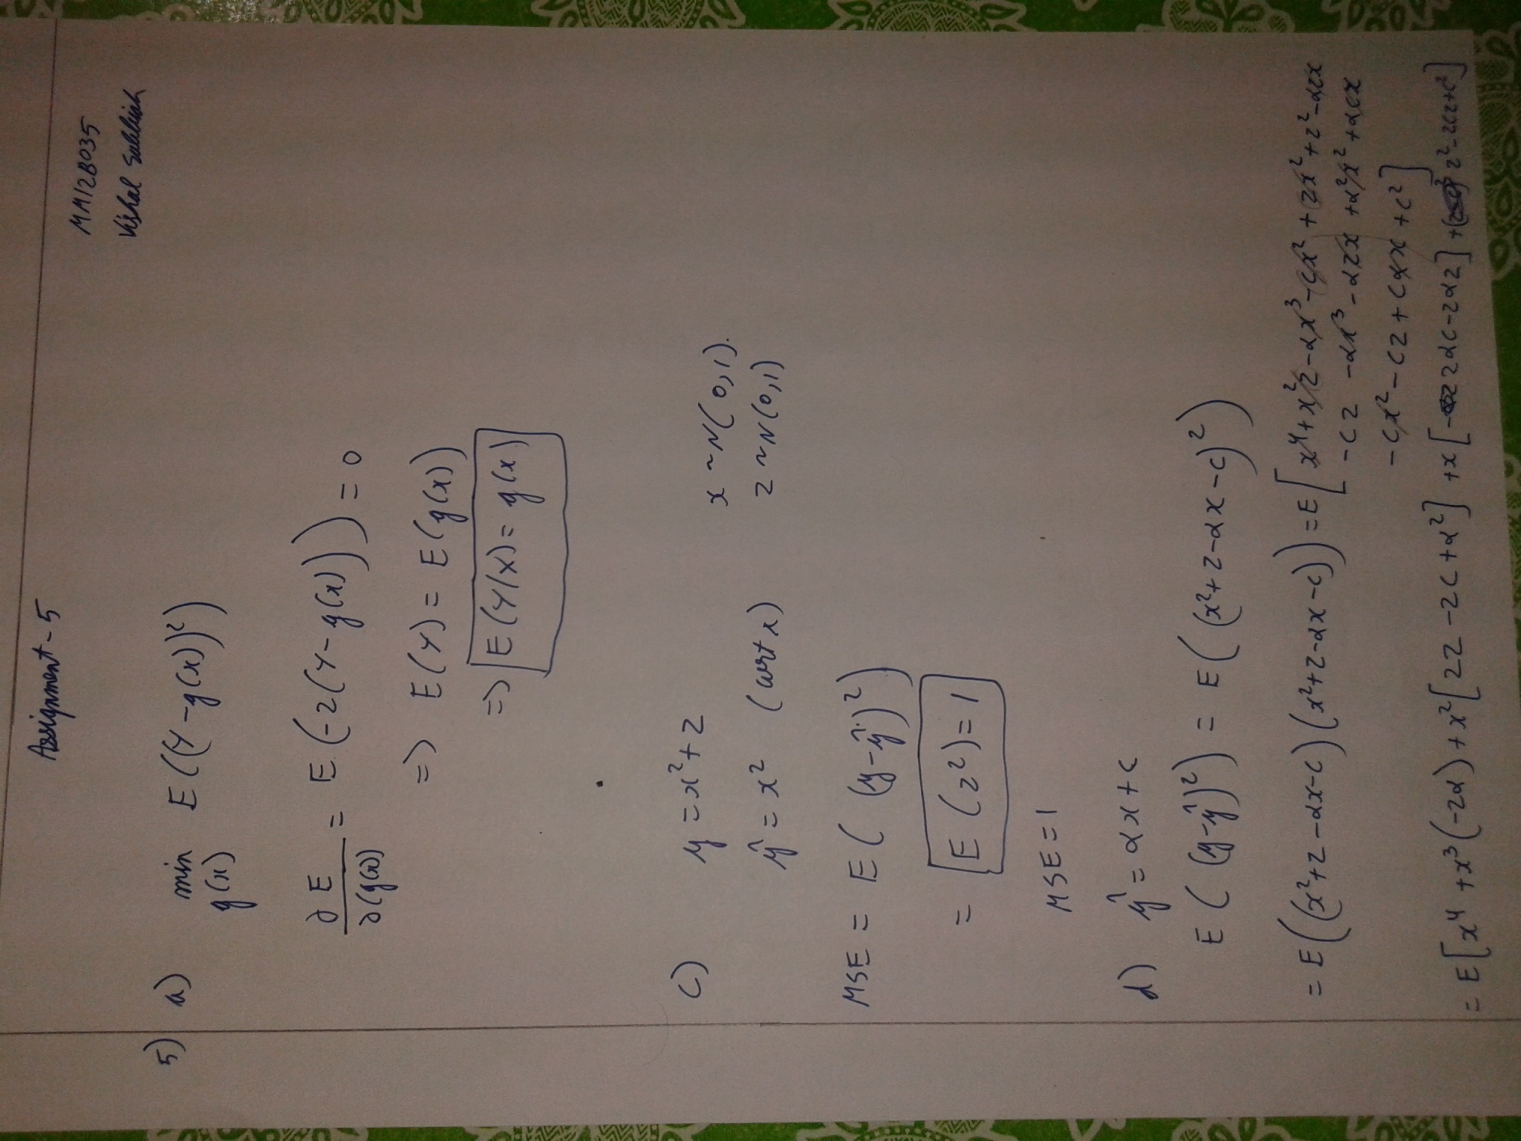

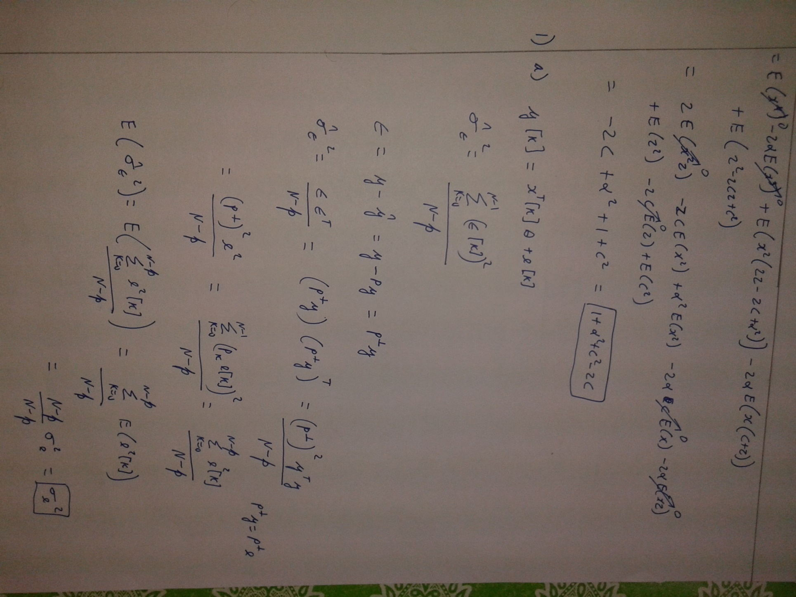

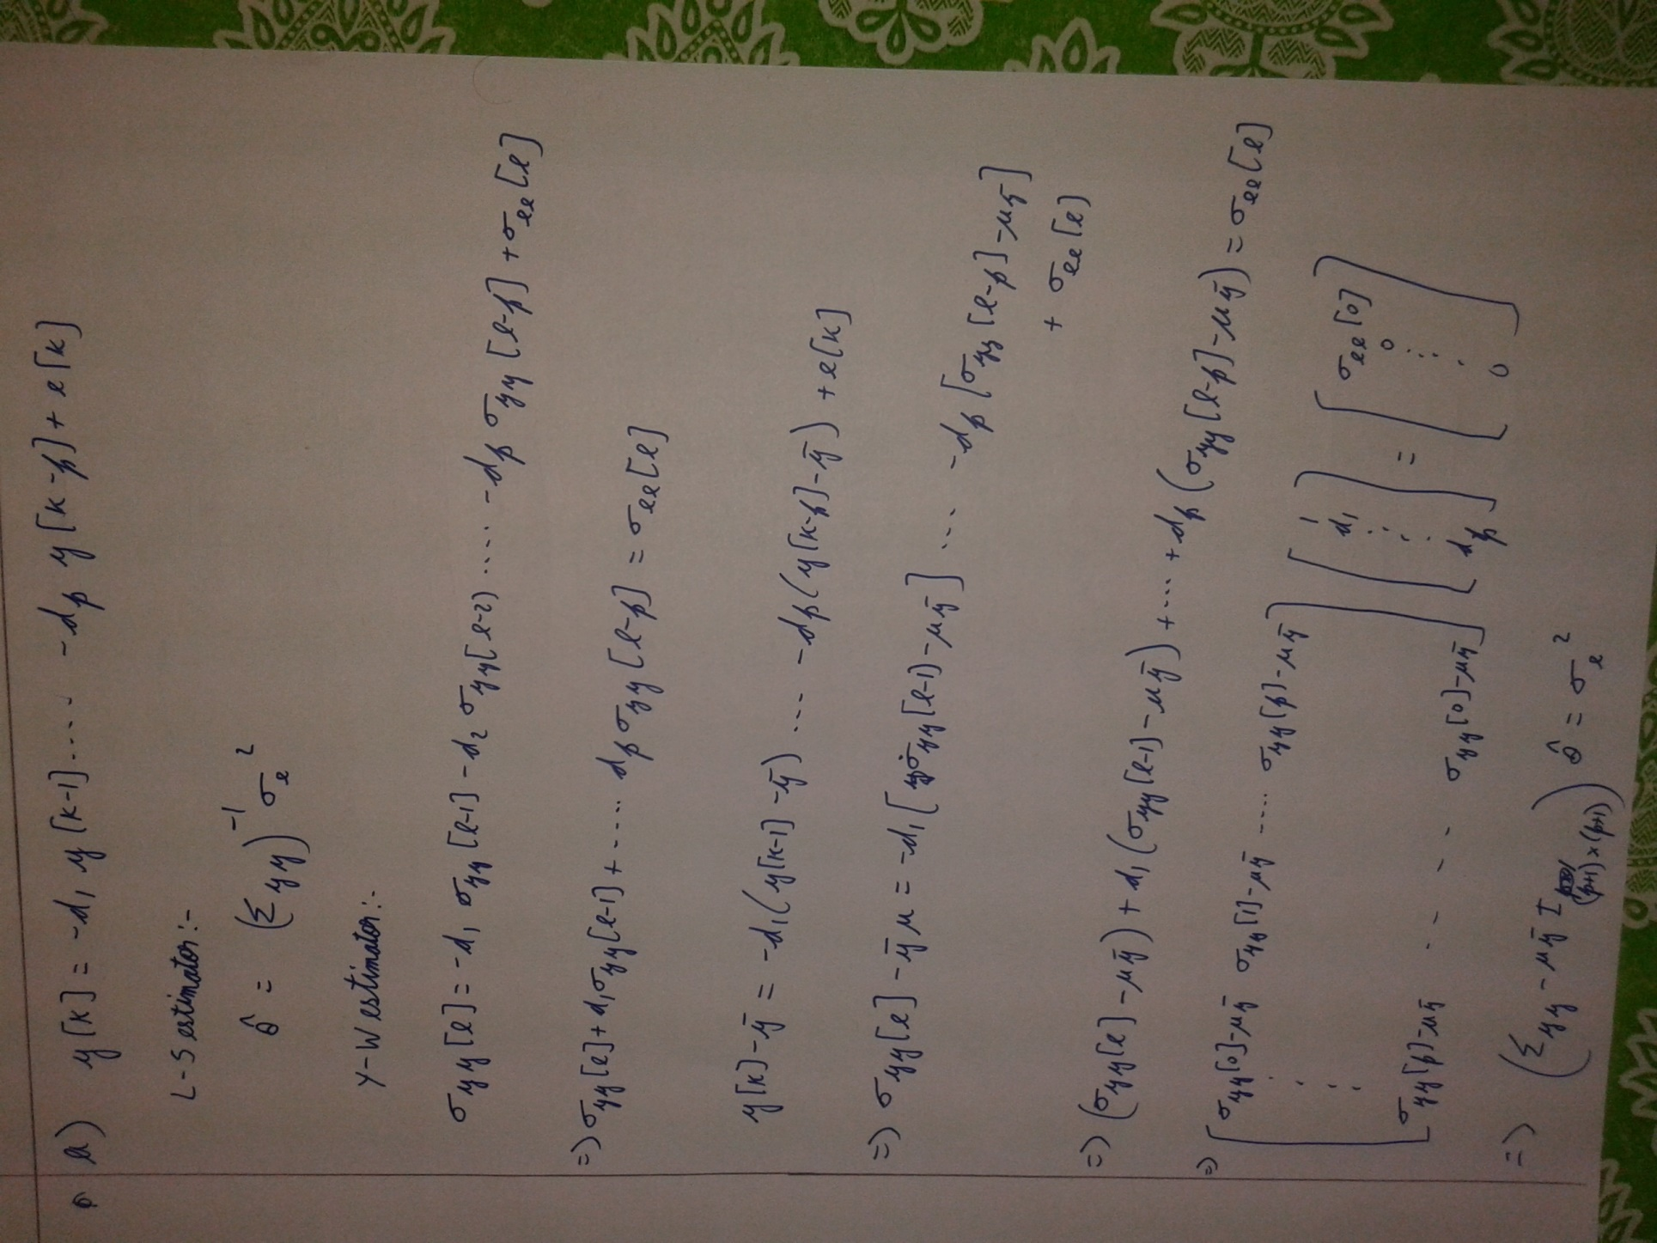

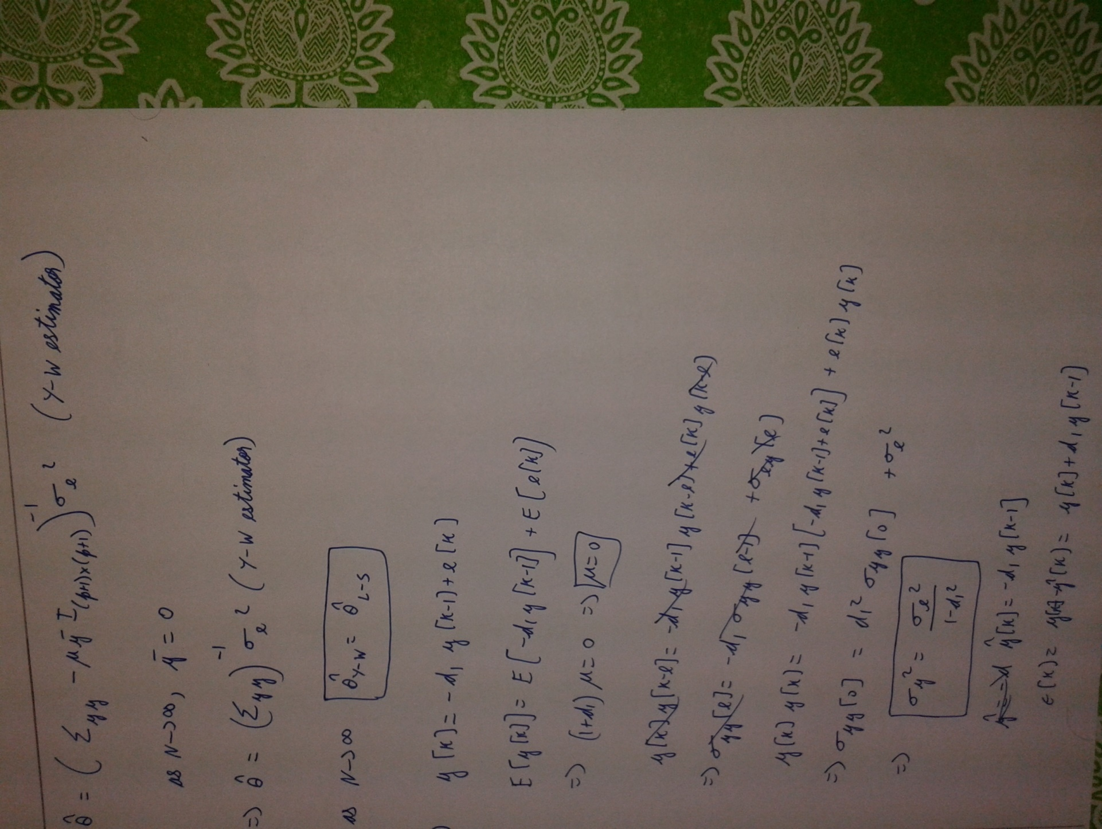

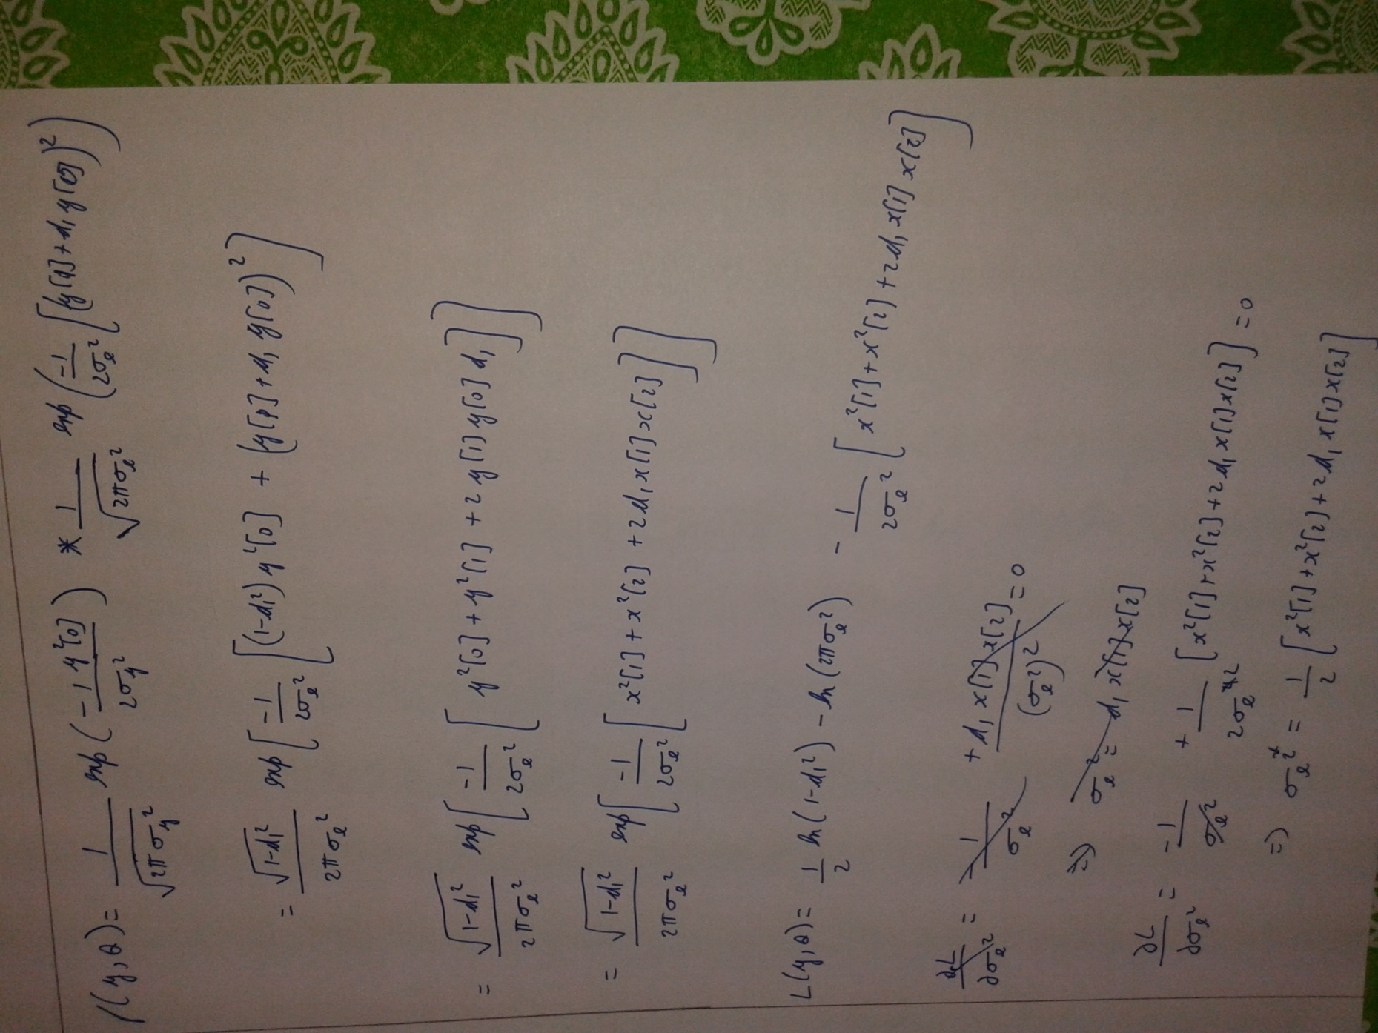

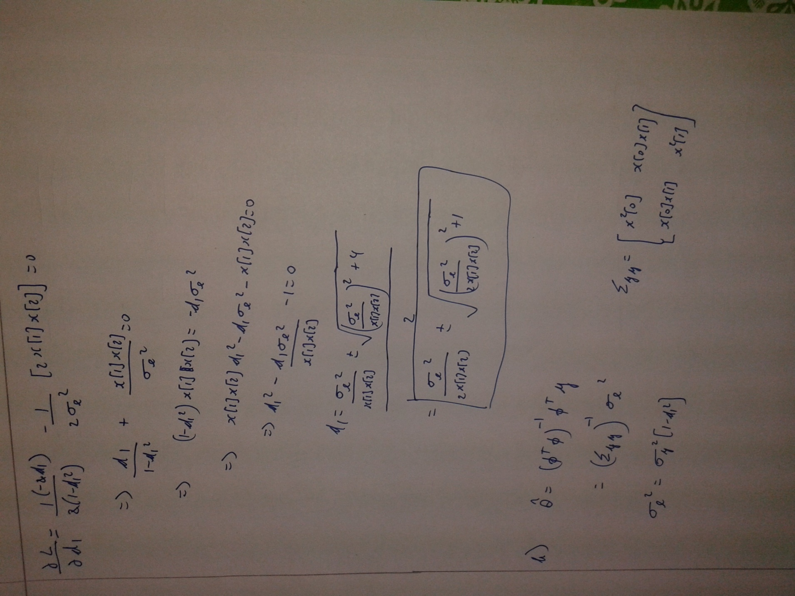

4b.R

Vishal Subbiah

Sun Nov 09 15:07:30 2014

load('sarima_data.Rdata')  
#plot(yk)  
#acf(yk,xlab="Lag",ylab='ACF')  
#pacf(yk)  
vk=diff(yk)  
acf(vk)

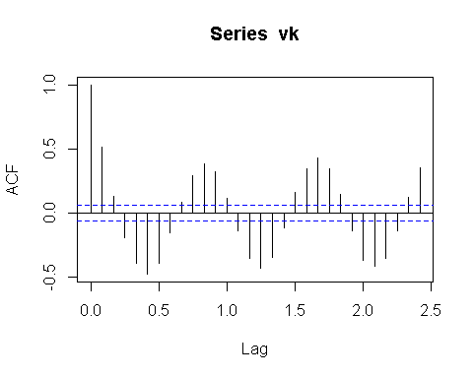

pacf(vk)

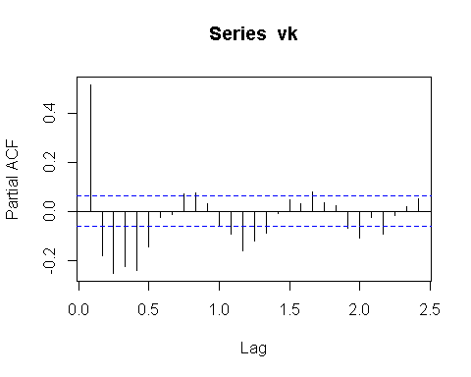

mod_sarima = arima(vk,order=c(3,0,5),seasonal=list(order=c(0,0,1),period=12),include.mean=F)  
print(mod_sarima)

##   
## Call:  
## arima(x = vk, order = c(3, 0, 5), seasonal = list(order = c(0, 0, 1), period = 12),   
## include.mean = F)  
##   
## Coefficients:

## Warning in sqrt(diag(x$var.coef)): NaNs produced

## ar1 ar2 ar3 ma1 ma2 ma3 ma4 ma5  
## 1.7802 -1.2625 0.1622 -1.4609 0.693 0.1477 0.0978 -0.0958  
## s.e. 0.0265 0.0429 0.0265 NaN NaN 0.0096 0.0059 0.0012  
## sma1  
## -0.0432  
## s.e. 0.0341  
##   
## sigma^2 estimated as 1.073: log likelihood = -1456.68, aic = 2933.37

tsdiag(mod_sarima,gof.lag=20)

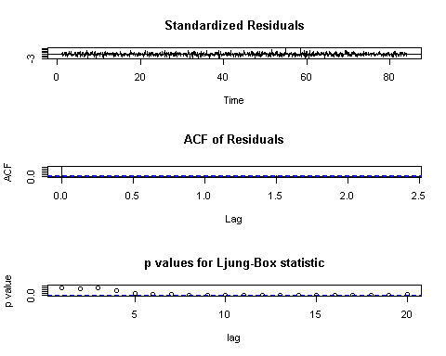

1c.R

vk1=arima.sim(n=1000,model=list(ar=c(1.1,-0.28)))  
ols_1=ar.ols(vk1)  
yw_1=ar.yw(vk1)  
vk2=arima.sim(n=10000,model=list(ar=c(1.1,-0.28)))  
ols_2=ar.ols(vk2)  
yw_2=ar.yw(vk2)

3.R

data(cmort)

vko=cmort[3:508]

vk1=cmort[2:507]

vk2=cmort[1:506]

mod_ar2_lr=lm(vko ~ I(vk1)+ I(vk2))

vk_yw=ar.yw(cmort)

vk_ols=ar.ols(cmort)

4a.R

load('sarima_data.Rdata')

yk_1=stl(yk,s.window="periodic")

#plot(yk,type='l')

sea_yk=yk_1$time.series[1:1000,1]# seasonal

tre_yk=yk_1$time.series[1:1000,2]# trend

sta_yk=yk_1$time.series[1:1000,3]# stationary

#plot(sea_yk,type='l')

#plot(tre_yk,type='l')

plot(sta_yk,type='l')

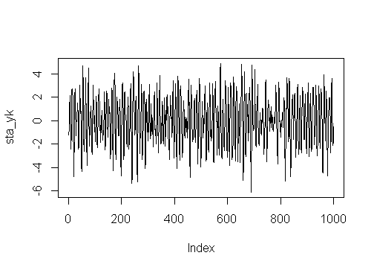

acf(sta_yk)

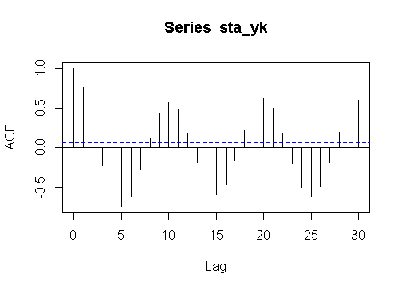

pacf(sta_yk)

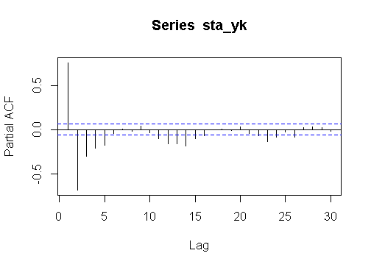

vk=arma(sta_yk,order=c(2,5))

acf(vk$residuals[10:1000], type="covariance") # residuals is white

